How to use mathtype software to write an equation

The firsts step is to install the mathtype in your computer. You can find the set up for the mathtype software in downloads section of course website. Here are given few examples to write in mathematical expression in mathtype.

- To write , open mathtype window, write x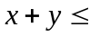and then in the second row of the tabs, go to the third tab to write superscript which is the first option in this tab as is shown in the picture shown below.

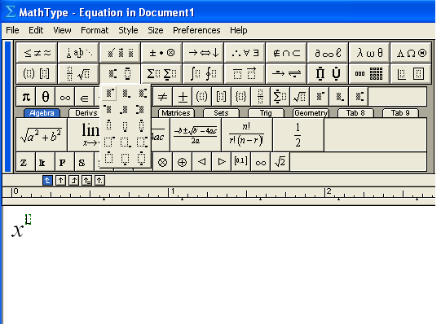
In the same tab, you can se the second button is for subscript. For writing superscript and subscript at the same time, use the third tab. Similarly, you can try the other options in this tab and explore the software by yourself.

- To write the inequality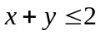, in order to write the inequality sign, click on the first tab in the first row, the first sign is your required inequality sign as is shown in the picture given below.

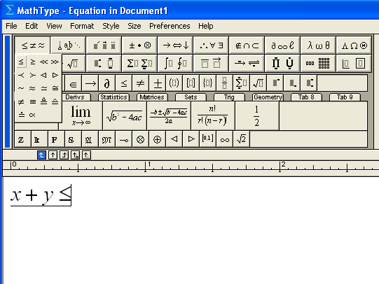

In the same way, you can explore all the other tabs as well to write your required mathematical expression.

